A000-Asia-China-Ding-Water Vessel with Inscription-Middle Zhou-Bronze- c 750 BCE

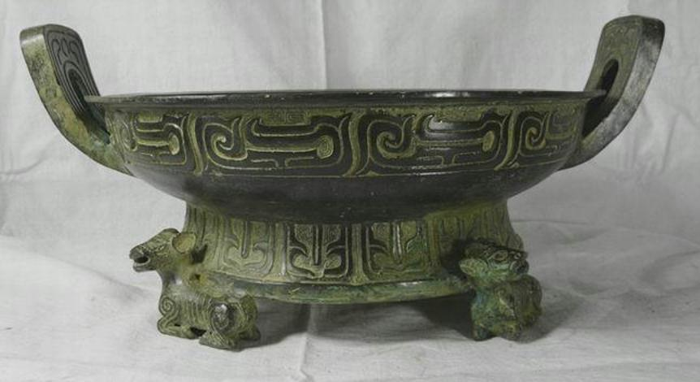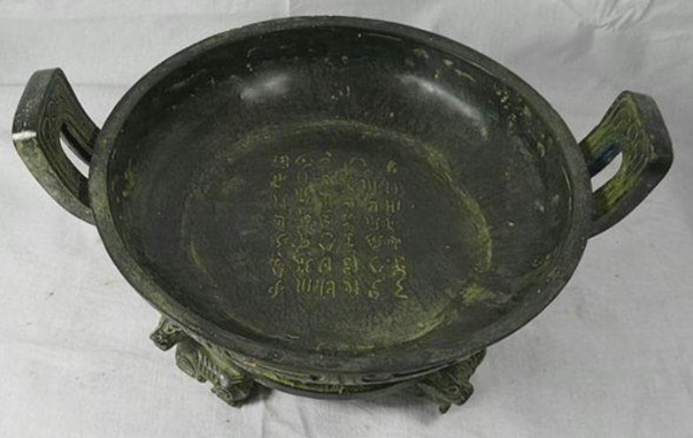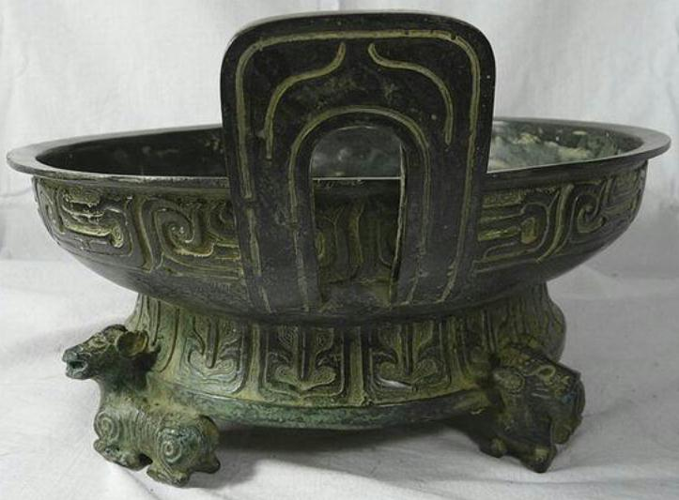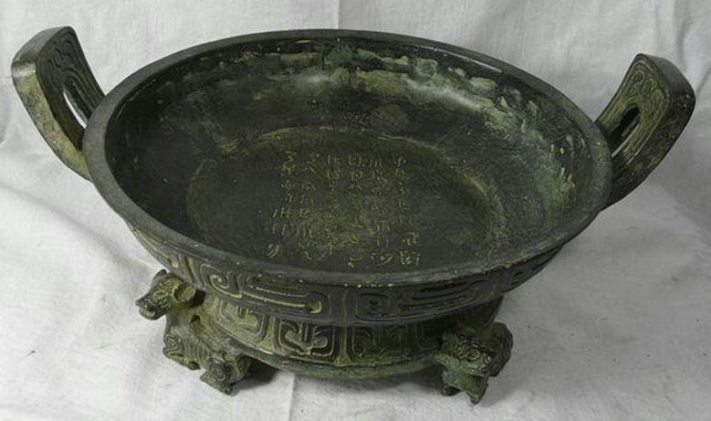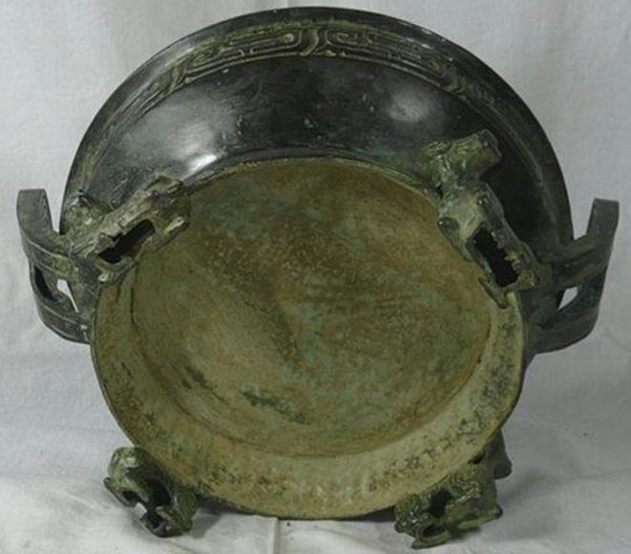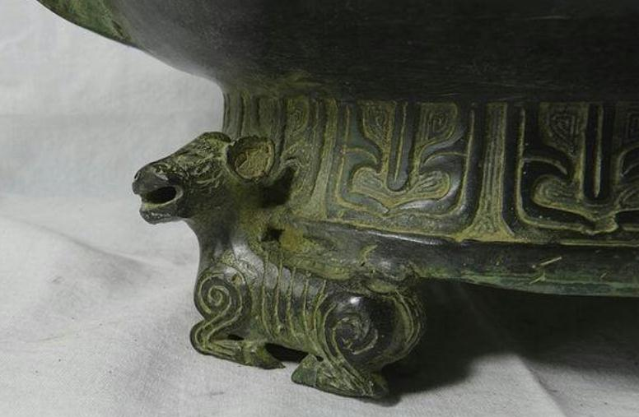

Figs. 1-6 Asia-China-Ding-Water Vessel with Inscription-Middle Zhou-Bronze- c 750 BCE **Case No.: 5**

**Accession No.**

**Formal Label:** Asia-China-Ding-Water Vessel with Inscription-Middle Zhou-Bronze- c 750 BCE

**Display Description:**

Zhou water vessels or P'an are noted for inscriptions that were cast to record events or pithy philosophical statements like this one in order to communicate them to ancestral spirits. This example is intended to be used as a mirror in which the owner peers into the water only to see beyond the surface a wise saying that is to be cogitated upon during the day. Increasingly middle Zhou inscriptions approached over 400 characters (So 1995: 105). These changes, completed by the 8th century BCE, mark the middle Zhou phase of bronze design.

Inscribing on bronzes, either by casting or engraving, is a characteristic of Chinese bronzes which makes them very uniquely different from those made in other cultures.

The rich textual repertoire debuted with mostly clan or ancestor names during Shang and early Zhou, and around the mid-period of Western Zhou increasingly adopted the theme of "For Descendants to Forever Cherish", which gradually developed into a standard finishing statement for many inscriptions. Other contents also abounded: chronicles of military actions, dowries in marital unions, ceremonies of conferment and endowment, contracts for land ceding, edicts and awards, and so on. They serve as original records vividly documenting what was done and said, delivered in the vocabulary and diction of the time.

The golden inscriptions are the end results of a series of processes which involve engraving, molding, and finally casting, of the handwritten originals; yet the cast texts still manage to reenact the superb calligraphy of the time. The calligraphic styles reflect the gradual development and forming of da zhuan (large seal script), evolving from powerful spontaneity of Shang and early Zhou, to solemn regularity during the mid-period, Western Zhou, and to refined smoothness from late Western Zhou to early Spring and Autumn period. That more and more long texts appeared during mid to late Western Zhou is also a live illustration of Zhou's "elaborate textual repertoire" "preserved in golden inscriptions".

**LC Classification:** NK7983.22

**Date or Time Horizon: 750- BCE**

**Geographical Area: Near Xi’an**

**Map:**

**GPS coordinates:**

**Cultural Affiliation: Middle Zhou**

**Medium: Bronze**

**Dimensions:** Height:16cm Length:35cm Diameter: 29cm

**Weight:**

**Condition: original**

**Provenance:**

**Discussion:**

**References:**

Deydier, Christian. 1989*.* [*Archaic Chinese bronzes from Shang and Zhou dynasties: June 12-June 30, 1989*](https://newcatalog.library.cornell.edu/catalog/4398588). London: Oriental Bronzes Ltd.

So, Jenny F. 1995. Eastern Zhou ritual bronzes from the Arthur M. Sackler collections. ew York, NY : Abrams